TASKPROTOCOLLER LOGIC DESIGN
Contents
1. General links 1
2. Admin Module 1
User authentication & access control 1
Roles and permissions 1
First-Login Setup 2
Admin and master interfaces 3
Admin UI 3
Master UI 6
3. Participants 6
Participant authentication 6
Participant interface 7
Questions? 7

General links
App in production: https://malenia.feld.cvut.cz/test/dist/#/
GitHub repository: https://github.com/maskopav/task_protocoller_web_app

Admin Module

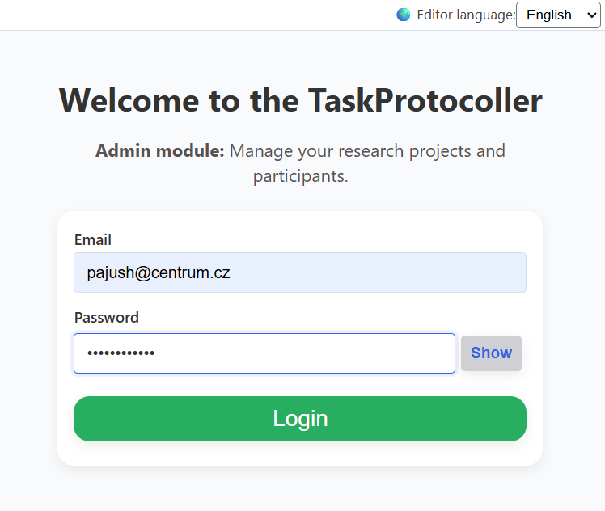
User authentication & access control
When an admin or master user opens the application, it redirects to /login, they must first log in using their email (or ID?) and password.
Authentication will verify credentials against the users table, check must_change_password flag and assign a role_id.

Roles and permissions
There are two user roles in the system:
Role | Permissions
Master | Full system control — can create, update, and delete all tables, manage projects, admins, and global settings. Only a few users should have this role.
Admin | Limited project-based control — can manage only assigned projects, their participants, and related data. Cannot see or modify other projects.

Each admin can manage one or multiple projects.
Each project can include multiple participants and multiple protocols (sets of tasks with specific order and parameters).

First-Login Setup
New admins can be created by masters. New masters can be created by ‘Master Paja’ by generating the hashed password using script hash_gen.js and inserting the user into DB.
HOW TO CREATE ADMIN: The Master user creates a new Admin in the AdminManagementPage by providing only an email and role. The system generates a temporary password and sets a must_change_password flag to 1 in the database.
- Credential Delivery: The Admin receives an email with their temporary credentials and a login link.
- Detection: When the Admin logs in, the adminLogin API returns the user data plus the must_change_password flag.
- Redirection: If the flag is 1, the frontend (via UserContext or App.jsx) automatically redirects them to a /setup-profile page.
- Onboarding Form: On this page, they use a form (similar as AuthForm) to:
  - Set a permanent password.
  - Confirm/Update their full_name and other personal details.
- Finalization: Once submitted, the backend updates the record and sets must_change_password to 0. The user is then redirected to their AdminDashboardPage.

Admin and master interfaces
After login, users see a AdminManagementDashboard.
The displayed elements depend on the user’s role.
The pages are displayed in the order as numbers; on each page there is an option to go back.

Admin UI
Upon login, the admin sees:

General Dashboard (project selection)
- Summary statistics for all available projects (admins projects), e.g.:
Project name | Descr | Start date | Country | N participants | Is active | …
Swiss_1 | A Project focused on… | 12.5.2026 | Switzerland | 35 | 1

- A project selector (mandatory before proceeding) – user has to click on the project in the table above to go further.

Project Dashboard (title includes project name)
- Summary statistics for selected project, e.g.:
Protocol name | Version | N participants | N tests | N questionnaires | …
Protocol_de | 1 | 35 | 5 | 1
Protocol_fr | 1 | 0 | 4 | 0

- Available actions:
Action | Description
3a) Participants | View, add, edit, or remove participants from the project. When adding the participant, the protocol must be assigned as well.
3b) Protocols | Design or edit protocols.
3c) Participant Protocol Enrollment | Generate unique links to send protocols to participants (both already must be created). Stop assignments of given protocol to participant.
3d) Data Explorer | Explore collected data and progress. (sessions, recordings,..)

3a) Participants
This section provides a table of participants within the selected project.
Actions:
- Add a new participant
Opens Participant personal info form just for identification of participant. The protocol has to be selected as well. After filling in the data:
- DB changes:
1. participants (INSERT): Insert participant identifying information (name, birth date, etc.). 2. project_protocols (LOOKUP): Find the id for the selected protocol version and the current project. 3. participant_protocols (INSERT): Create a new record linking the new participant_id and the project_protocol_id. Generate and store a unique_token.
- Edit participants
- Select subject → opens Participant personal info form prefilled from database.
- DB changes:
1. participants (UPDATE): Update fields like full_name, contact_email, etc., for the selected participant. Set updated_at = now().

3b) Protocols
This section provides a table of participants within the selected project.
Actions:
- Create new protocol:
Define name, language, tasks, and parameters -> save to protocols as new entry
- DB changes:
1. protocols (INSERT): Insert new record. Assign a NEW protocol_group_id (since it's a new protocol). Set version = 1. Set is_current = true. 2. protocol_tasks (INSERT): Insert records for each task selected, referencing the new protocols.id (version 1) and storing the task-specific params jsonb.
- Create new protocol from existing protocol:
Define new name → current protocol tab already prefilled, ready for edit → save with changes to protocols as new entry
- DB changes:
1. protocols (INSERT): Insert new record. Assign a NEW protocol_group_id (due to the new name, it's a new family of protocols). Copy all data from the source protocol. Set version = 1. Set is_current = true. 2. protocol_tasks (INSERT): Duplicate all task records or modify it (based on what admin modified) from the source protocol, referencing the new protocols.id.
- Edit existing protocol:
Update version → current protocol tab already prefilled, ready for edit → overwrite → save updates to the protocols table with version incremented
- DB changes:
1. protocols (UPDATE/OLD VERSION): Find the currently active version (say, V2) using the protocol_group_id. Set its is_current = false. 2. protocols (INSERT/NEW VERSION): Insert a new record. Use the same protocol_group_id. Set version = current_version + 1 (e.g., 3). Set is_current = true. 3. protocol_tasks (INSERT): Duplicate the previous version's tasks, but apply the new edits. Reference the NEW protocols.id (V3). NOTE: Existing participants stay on the version they were assigned (V2).

4b) Protocols creation
The page is split into two panels:
- Left: available tasks
- Right: current protocol configuration
  - Option to change current_protocol name, add questionnaire, change protocol language
Workflow:
- Select tasks from available tasks pool
  - After clicking on task, edit modal appears user must edit or confirm selected params, which can be modified also later
- Add optionally questionnaire, change protocol language or reorder selected tasks
- Save protocol
Personal questions can be included in questionnaire.
Additionally, there is button of view current protocol (protocol will be displayed in test mode and data won’t be saved).

3c) Protocol assignments
- Assigning protocol to existing subject
Admin has to confirm that protocol will be sent to the patient. After submitting that, generated link (possibly generated QR code with draft of email to participant will be displayed).
- DB changes:
1. project_protocols (LOOKUP): Find the correct id for the selected protocol version and project. 2. participant_protocols (UPDATE): Modify an existing record linking the existing participant_id and the project_protocol_id. Set is_active = true. Fill in start_date.

- End the protocol assignment for subject/subjects
Select protocol → select participant(s) → updates participant_protocols: sets end_date and is_active = false.
- DB changes:
1. participant_protocols (UPDATE): For the selected records, set is_active = false and end_date = now().

3d) Data Explorer
TO BE DONE LATER…

Master UI
Master users see everything the Admin sees, plus:
- Manage all admins
- Manage all projects
- System-wide controls (e.g., protocol libraries, configuration, permissions)

Participants

Participant authentication
Participants (patients, subjects) have two options:
  - Direct assignment link (no login)
→ participant opens unique URL /participant/<participant_protocol_token>
→ no login
→ the server loads participant_id + project_protocol_id (protocol + tasks + session) directly
→ saves recordings to correct participant + protocol + session
  - Login-based access via project_protocol link
→ participant opens link /protocol/<project_protocol_token>
→ 2 options:
      - login
- user enters credentials
- server finds participant
- server checks if that participant is already assigned to this project_protocol
- if NOT → assign them
- redirect to their /participant/<participant_protocol_token>
      - register
- user fills in personal info
- server creates new participant
- server assigns them to this project_protocol
- redirect to their /participant/<participant_protocol_token>

Participant interface
Participants access their test session via the unique link generated for them. No login is required. The interface loads assigned protocol (tasks in defined order with specified parameters, language, questionnaire, etc.

Questions?
- FREQUENCY DEFINITION: Which layer should it be defined on: projects, protocols or participants? Where should the user select it, and should this option be available always?
    - Will be solved later – would be needed if SMS API would be used, now not that important, admins would have to check by their own, if the participants fill the data carefully and periodically
- TOKEN STRUCTURE: This is the tricky part – should there be a unique token for each project/protocol and subject? What about the unique link created from that? If not, participants would need to log in and it would be easier for me.
  - Pros: No login required for participants, personalised and secure.
  - Cons: Admins must send separate URLs to each participant.
    - Proposed solution:
      - Suggest that login won’t be needed, but if so, the unique token logic would remain same, the user would just get generated login credentials and after successful login, the url would be similarly generate from tokens…
- PERSONAL INFO FORM ALONG WITH PROTOCOL
    - Proposed solution:
      - Probably wide personal info database wont be needed, it is redundant to duplicate these forms – if it would be needed, personal info form can be coded as Questionnaire….

